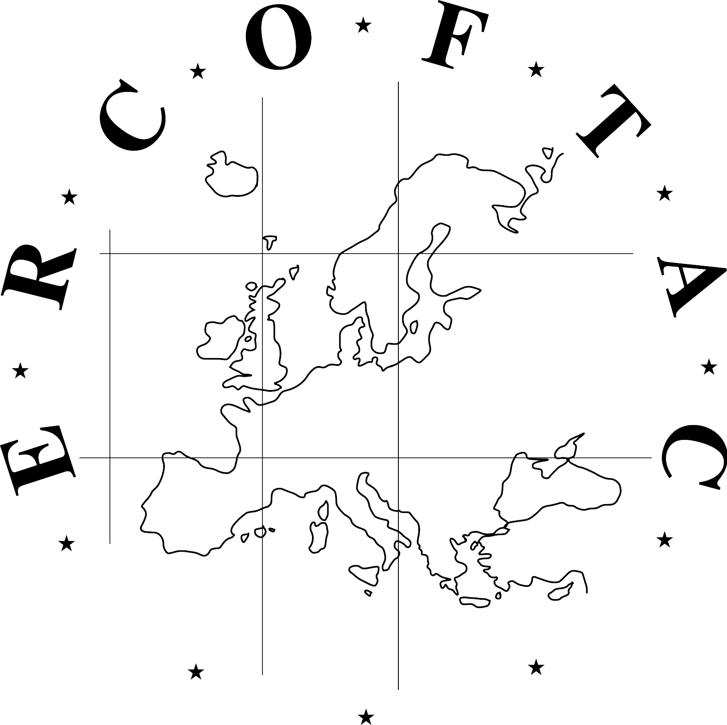
ERCOFTAC Autumn Festival
European Research Community On Flow, Turbulence And Combustion
Da Vinci Competition
15 -16 October 2014,
CORIA UMR 6614, Rouen, France

Please complete registration form and send as soon as possible and before 21st September 2014 to my email address: magdalena.jakubczak@ercofatc.org indicating as subject: “ERCOFTAC registration”. Thank you very much in advance.

1 – Personal details

LAST NAME (in capitals)

First name
Title: Prof. Dr. Mr. Ms. Student Other

Position
Organization

Business Address
City State
Post/Zip code Country

E-mail:

2- Details for organisation for ERCOFTAC autumn festival

Arrival date in Rouen:

Departure date:

Your hotel in Rouen:

You attend to participate:

Wednesday, October 15th:

- Welcome reception & registration 09:00 am- 09:30 am YES NO
- Lunch* in the conference site YES NO
- Pedestrian guided tour of Rouen (07:00 pm – 08:30 pm) YES NO
- Dinner* (08:30 pm) in a restaurant down town YES NO

Thursday, October 16th:
- Lunch* in the conference site YES NO

* Please indicate if special diet is required:

